**National Exam of Higher National Diploma 2023 Session**

RÉPUBLIQUE DU CAMEROUN

Pais-Travail-Patrie

.............

MINISTÈRE DE L'ENSEIGNEMENT SUPÉRIEUR

.............

COMMISSION NATIONALE D'ORGANISATION DE L'EXAMEN

HIGHER NATIONAL DIPLOMA EXAM (HND)

..............

REPUBLIC OF CAMEROON

Peace-Work-Fatherland

..............

MINISTRY OF HIGHER EDUCATION

..............

NATIONAL COMMISSION FOR THE ORGANISATION OF

HIGHER NATIONAL DIPLOMA EXAM (HND) EXAM

..............

**Specialty/Option: SOFTWARE ENGINEERING (SWE)**

**Paper: DIGITAL ELECTRONICS**

**Duration:4 HOURS credit:7**

***Instructions:*** *Answer all question. Calculators of any sort are not allowed*

**SECTION A: NUMBER SYSTEMS AND CODES (20 marks)**

**MCQs, for each question, four answers are proposed. Write the letter for the correct**

**answer against the question number. Each question carries 1mark.**

1) The value of radix in binary number system is

a) 2

b) 8

c) 10

d) 1

2) Which of the following is not a binary number?

a) 1111

b) 101

c). l1E

d).000

3) Positive integers must be represented by

a) signed numbers

b) unsigned number

c) Both A and B

d) None of above

4) An unweight code in which only one bit changes from one code number to the next is:

a) BCD

b) Excess-3

c) Gray

d) ASCII

5) In the decimal numbering system, what is the MSD?

a) The middle digit of a stream of numbers

b) The rightmost digit to the decimal point of the number

c) The last digit on the right

d) The digit with the smallest weight

6 The following BCD number: 0010, 1000.0111 0100 corresponds to the decimal number:

a) 28.72

b) 29.52

c) -28.70

d) 28.82

7) How many binary digits are required to count to 10010?

a) 100

b) 3

c) 7

d) 2

8) Which of the following logical operations is represented by the + sign in Boolean algebra?

a) Inversion

b) AND

c) OR

d) complementation

9) The binary equivalent of gray code 1111 is

a) (1101)2

b) (1011)2

c) (1110)2

d) (1010)2

10. The BCD number for decimal 347 is

a) 110010111000

b) 00110100 0111

c) 00110100 0001

d) 110010110110

11. Convert binary to octal: (1 10110001010)2=?

a) (5512)s

b) (6612)s V

c) (4532)8

d) (6745)s

12. What is the addition of the binary numbers 11011011010 and 010100101?

a) 0111001000

b) 1100110110

11101111111

d) 10011010011

13. Binary subtraction of 100101 - 011110 is

a) 000111

b) 111000

c) 010101

d) 101010

14. Perform multiplication of the binary numbers: 01001 x 01011

a) 01100011

b) 110011100

c) 010100110

d) 101010111

15. Divide the binary numbers: 1010001 + 1000

a) 1010.001

b)1000.001

c)1100.001

d) 0011.001

16. Which numbering system uses numbers and letters as symbol?

Decimal

a) Decimal

b) Binary

c) octal

c) Hexadecimal

17. The octal number (651.124)8 is equivalent to

a) (1A9.2A)16

b) (1B0.10)16

c) (1A8.A3)16

d) (1BO.B0)16

18. The sign of a negative binary number is given by by its

a) MSB

b) LBS

c) Byte

d) Nibble

19. Which of the following is a correction detection code?

a) Gray code

b) Hamming code

c) UNICODE

d) Parity code

20. The format used to present the logic output for the various combinations of a logic expression-is called:

a) Boolean constant

b) Boolean variable

c) Truth table

d) Logic function

**SECTION B: COMPUTER FUNDAMENTAL (80marks)**

**1) Hardware (20 Marks)**

1) Define the following acronyms:

a) RAM

b) SDRAM

c) EEPROM

d) ROM

e) DRAM

2)Name the following devices and give their roles

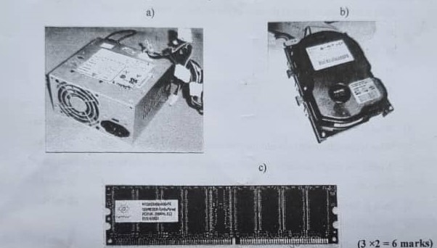

3) What is the main difference between mainframes computers and supercomputers (2marks)

4) Given the following diagram below

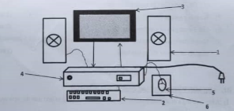

1. Identify the following components from 1 to 6 (3marks)
2. Identify two inputs and output devices (4marks)

**II) Network And Mobile Devices (40Marks)**

1)Give brief description of the each of the following network devices

a) Router

b) Switch

c) Access point

d) Firewall

e) Repeater (5x 2 marks)

2)What is the Internet? (2marks)

3) What is the difference between Internet and intranet? (2 marks)

4)A company might decide invest in an intranet. What are the benefits of this type of

network? (2 marks)

5) How is Internet different from intranet? (2 marks)

6) Network can be classified using various criteria

a) Classify networks based on geographical distances. (5 marks)

b) Classify networks based on the media of transmission. (3 marks)

c) What network type is suitable for a single school campus? (1 mark)

d) What transmission media is preferable for the network in (C) above (1 mark)

e) Can Optic fiber be used in a campus network? Explain. (2 marks)

7) What is a mobile device? (2 marks)

8) List 3 examples of a mobile device. (3 marks)

9) Mobile devices come equipped with hardware for functionality List 5 common

Features a smart phone can have (5 marks)

**III) Microsoft Word, Excel And PowerPoint (20 Marks)**

1) After creating a new word 'document a user can start typing in text into the new work space

a) What is the default tab for a new document (1 mark)

b) what file extension does a word document save in (1 mark)

c) which tab is used to add illustration to a word document (1 mark)

d) What is the role of the format painter in a Word document? (1 mark)